**SQL Lesson 1: SELECT queries 101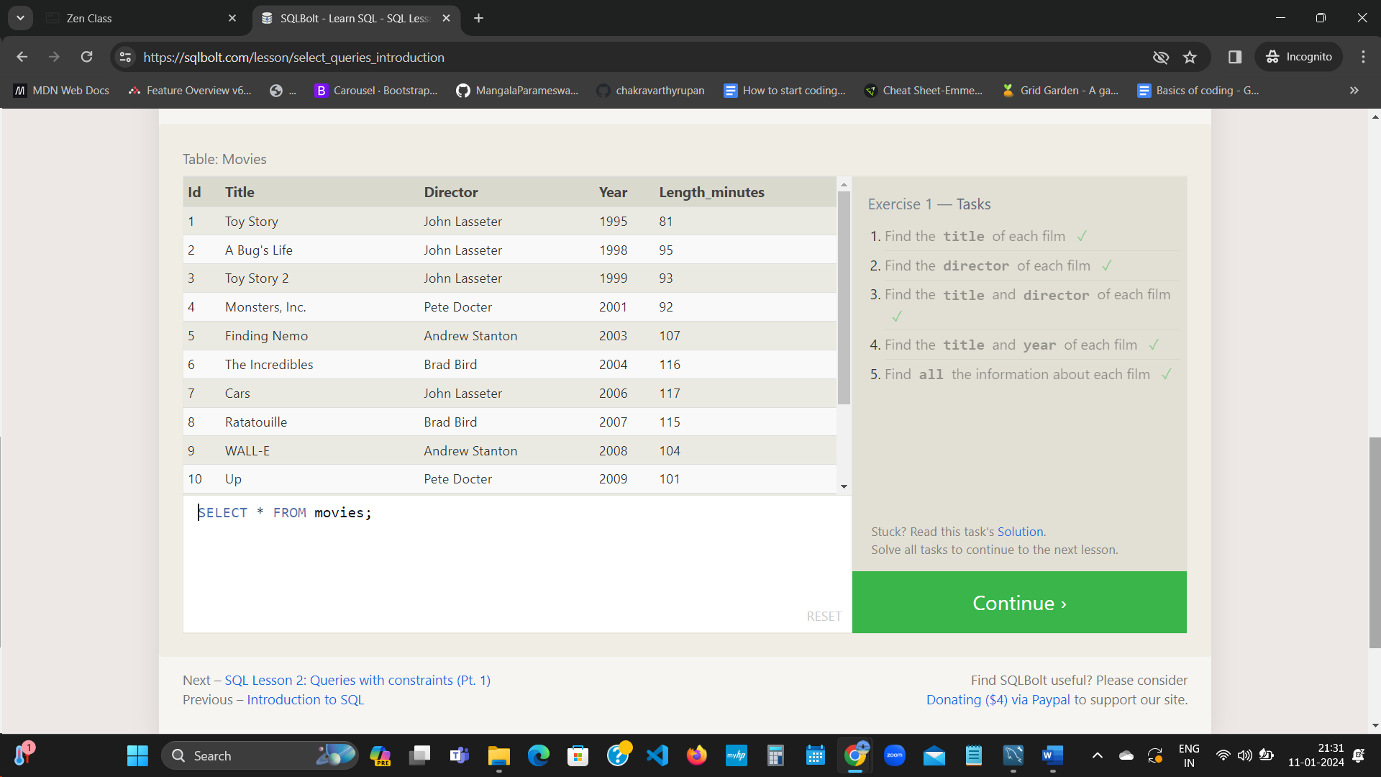 SQL Lesson 2: Queries with constraints (Pt. 1)**

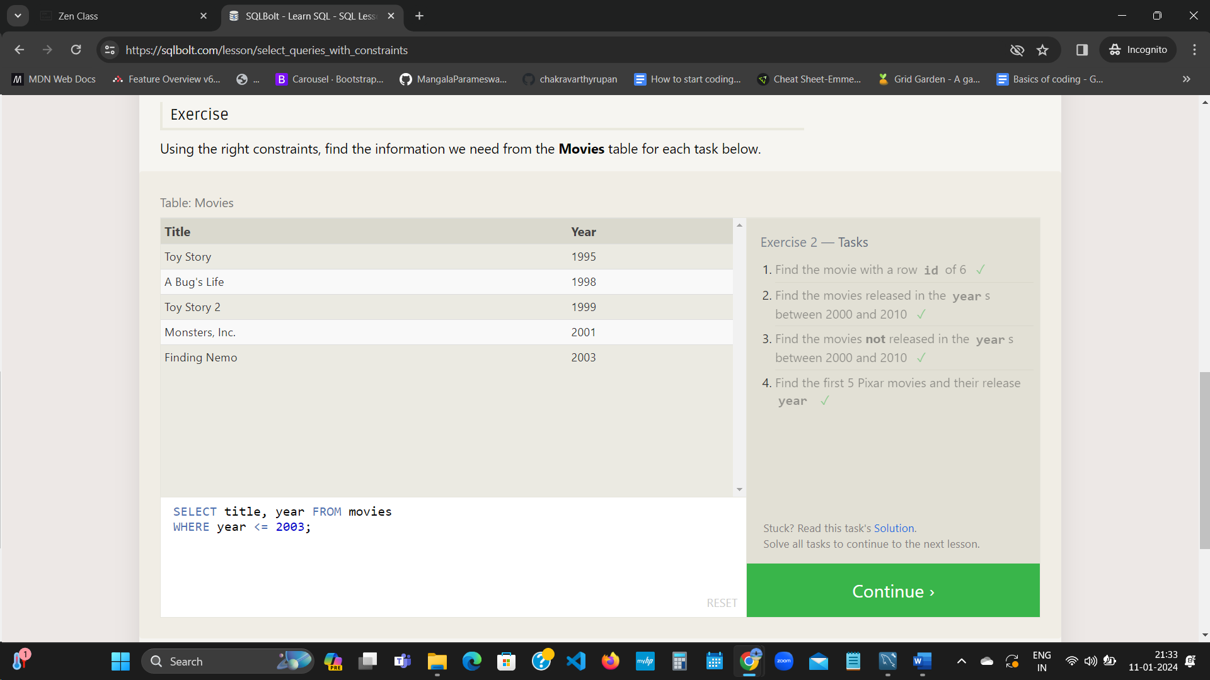  
  
  
**SQL Lesson 3: Queries with constraints (Pt. 2)**

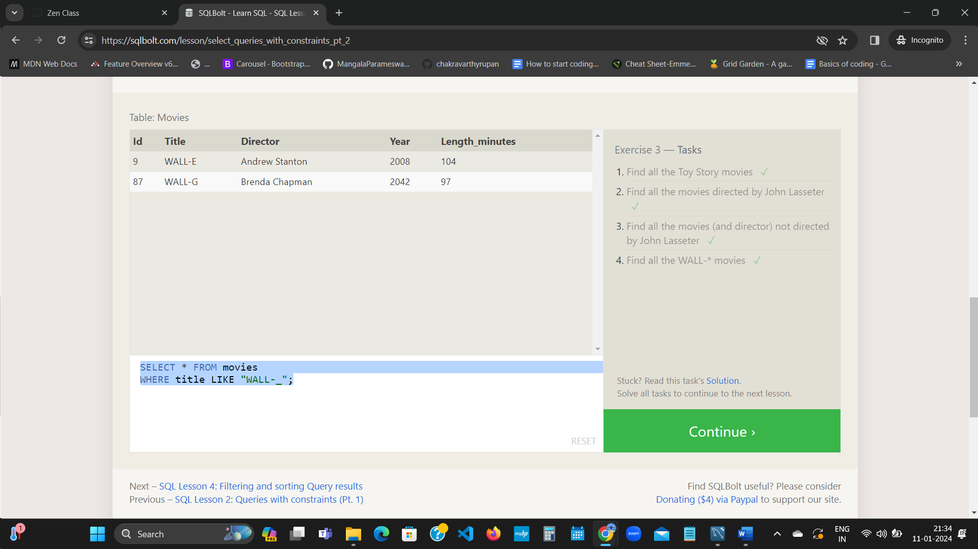  
  
  
**SQL Lesson 4: Filtering and sorting Query results**

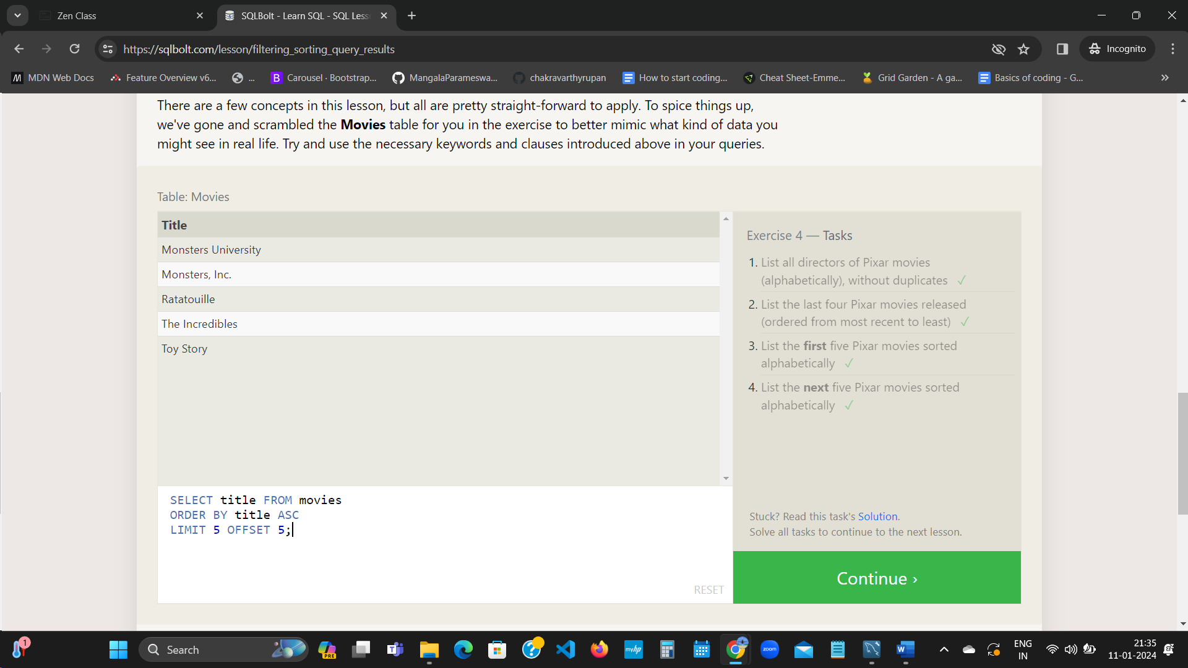  
  
  
**SQL Review: Simple SELECT Queries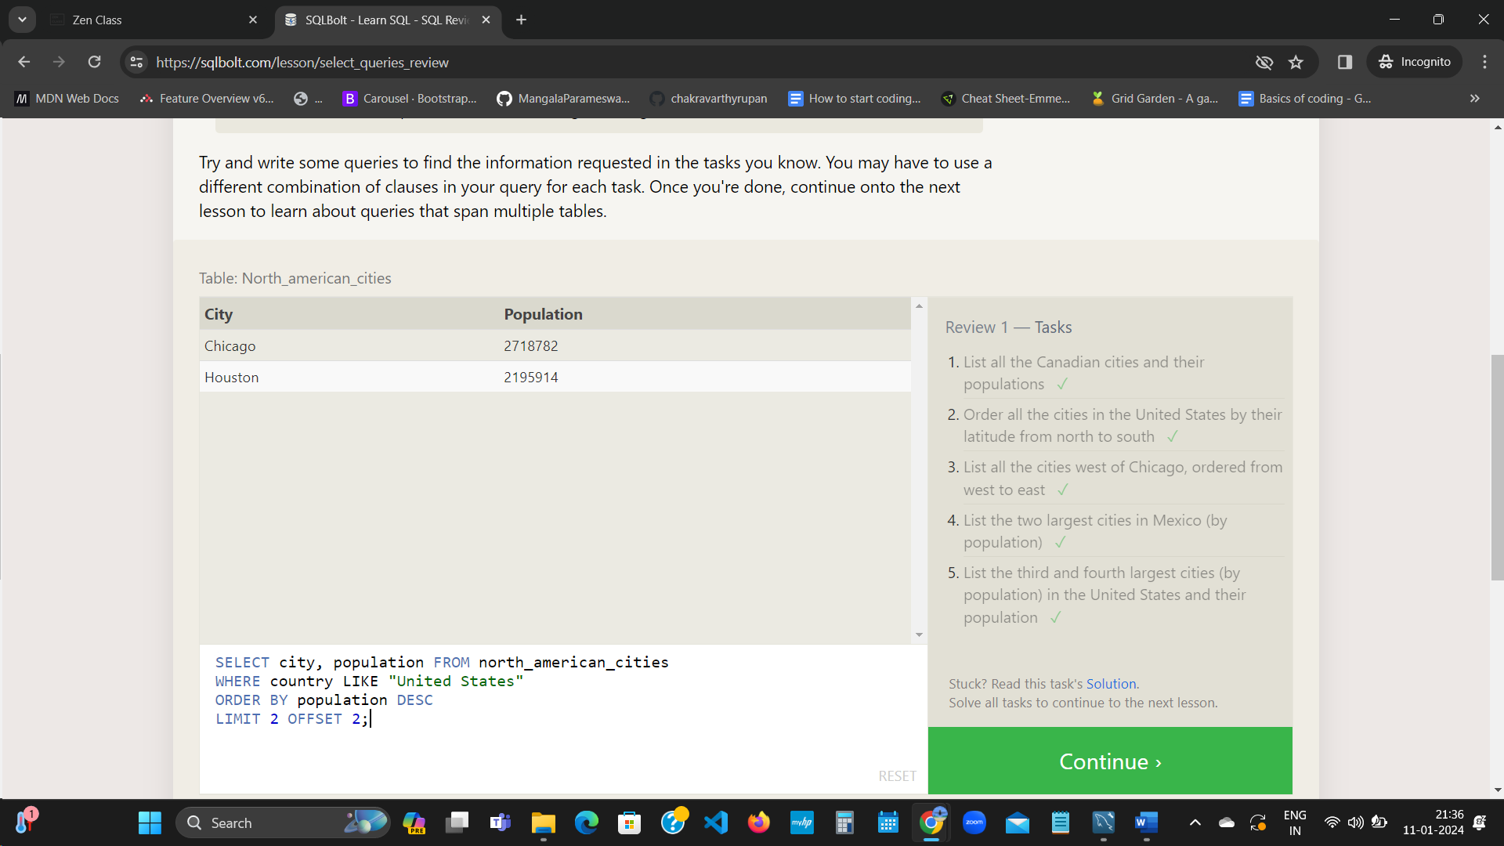 SQL Lesson 6: Multi-table queries with JOINs**

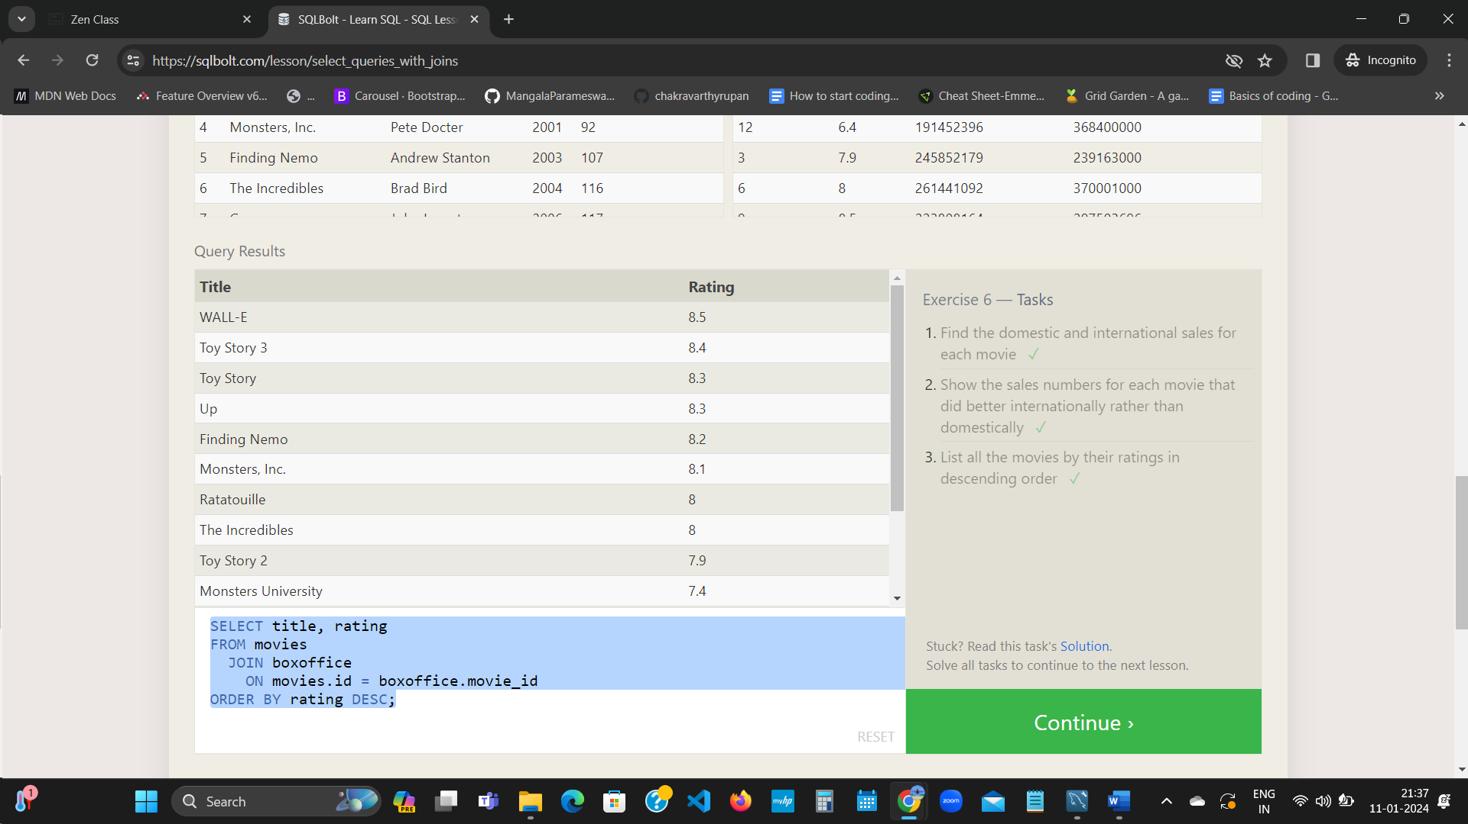 **SQL Lesson 7: OUTER JOINs**

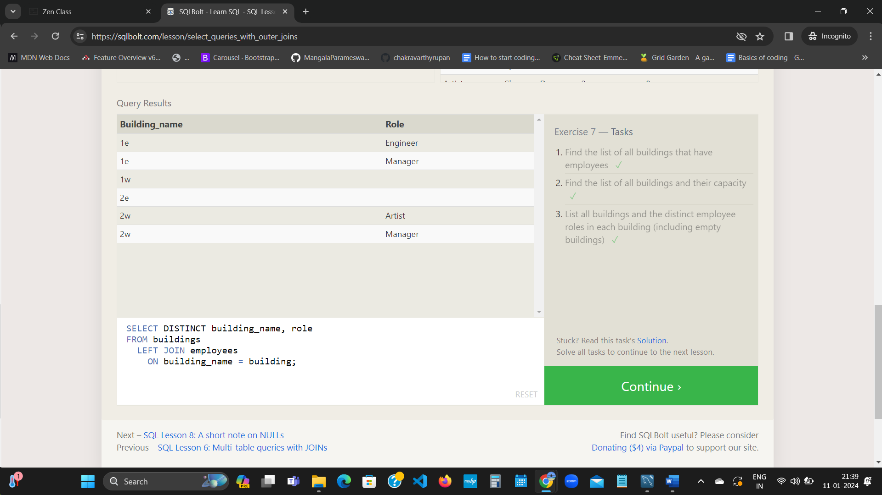 **SQL Lesson 8: A short note on NULLs**

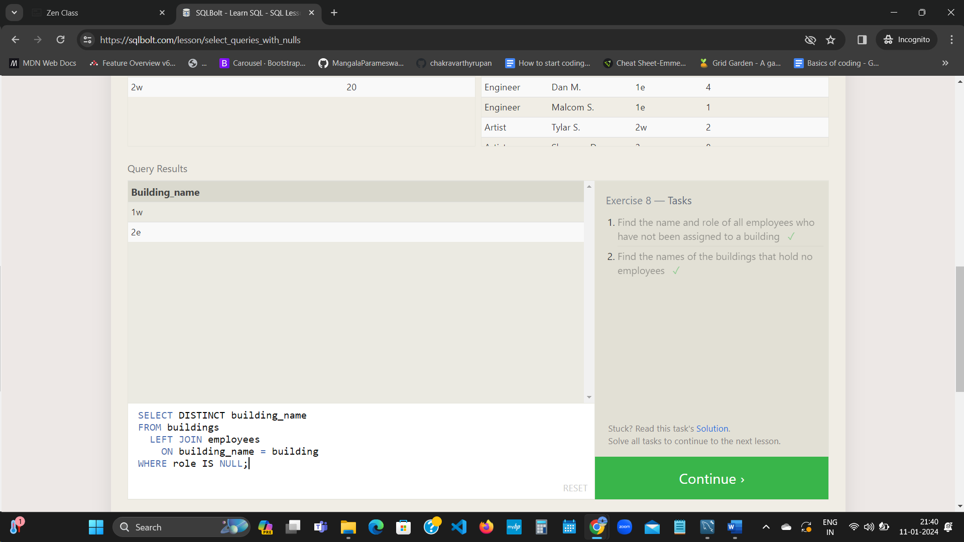 **SQL Lesson 9: Queries with expressions**

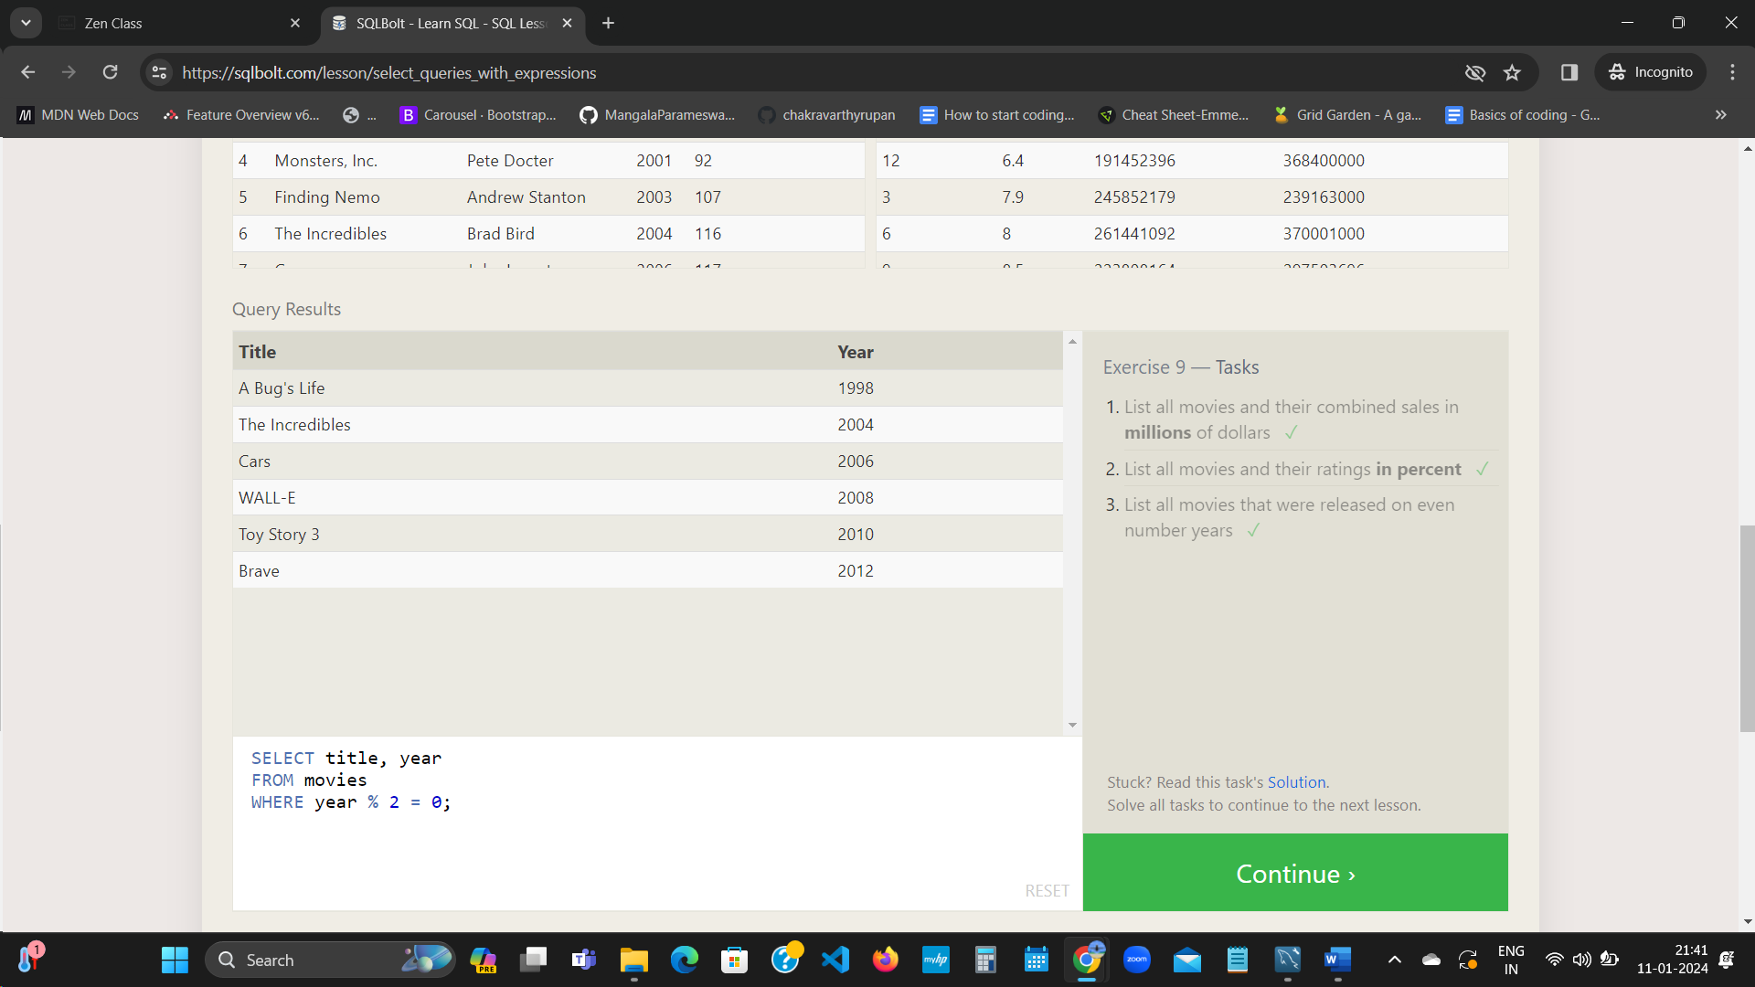 **SQL Lesson 10: Queries with aggregates (Pt. 1)**

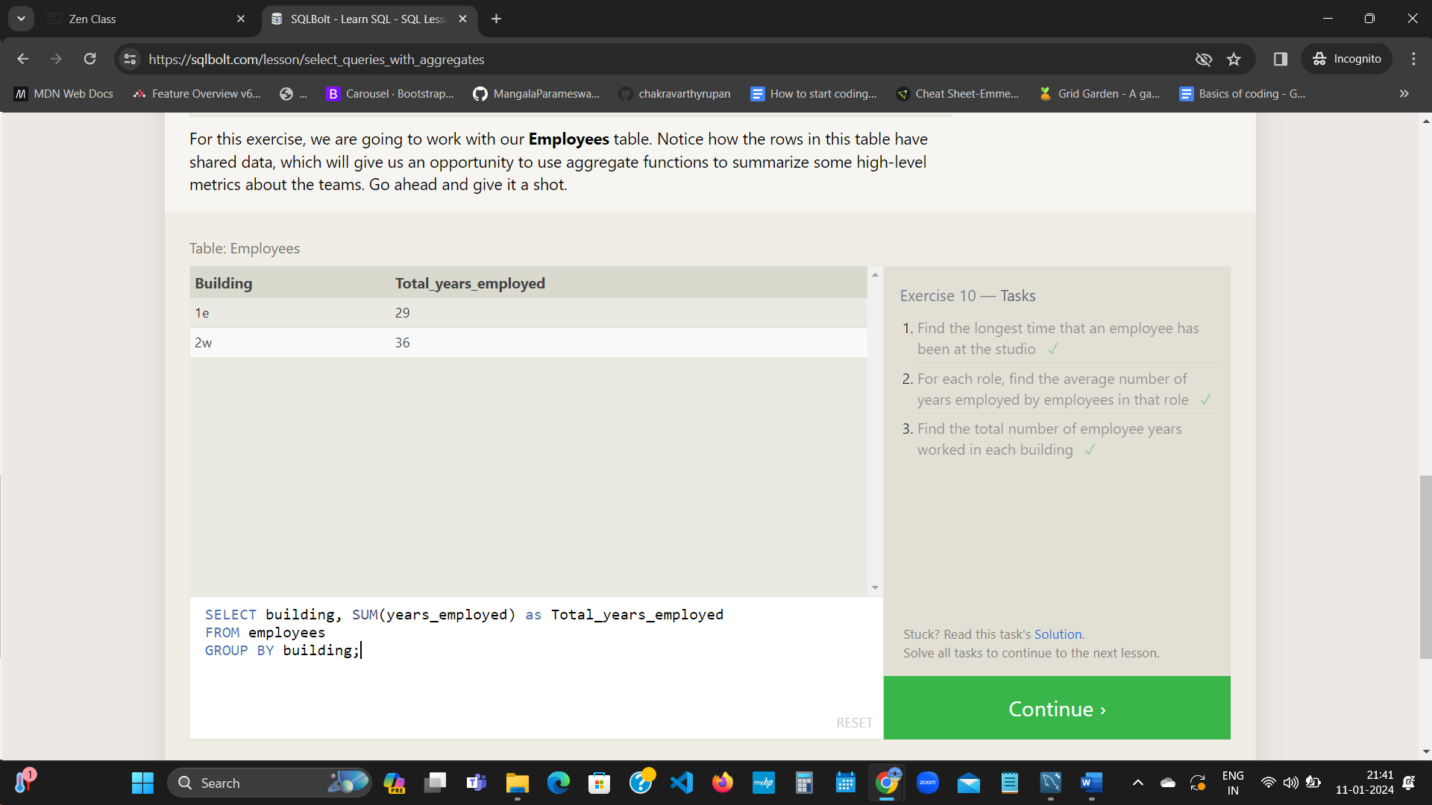 **SQL Lesson 11: Queries with aggregates (Pt. 2)**

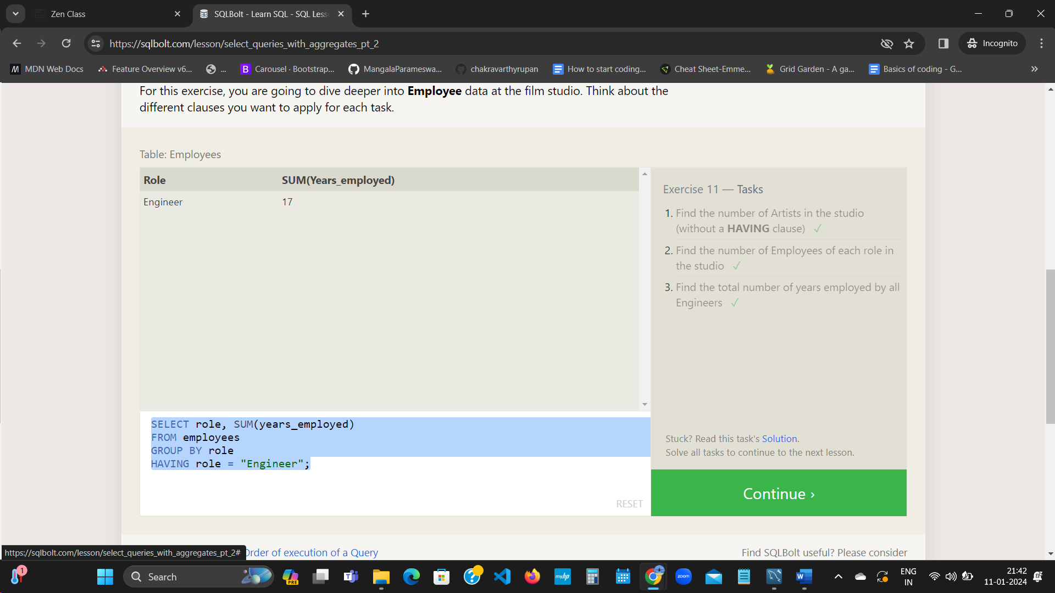 **SQL Lesson 12: Order of execution of a Query**

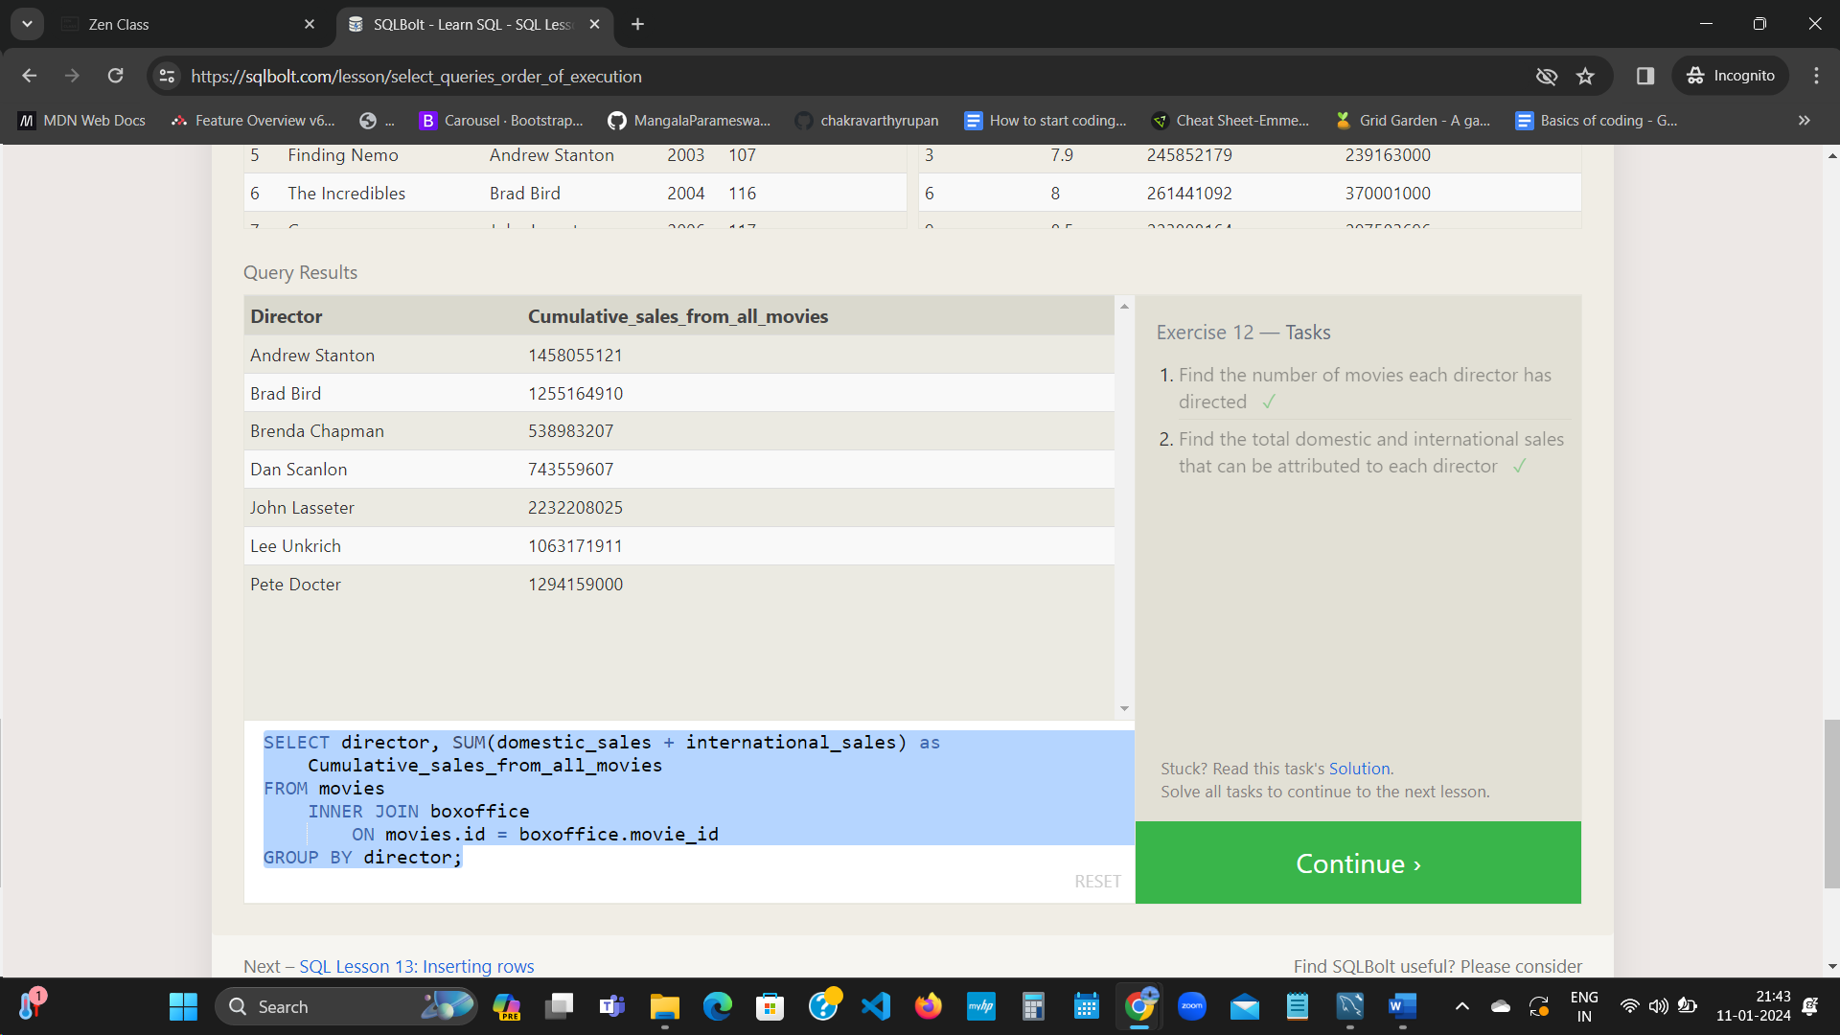 **SQL Lesson 13: Inserting rows**

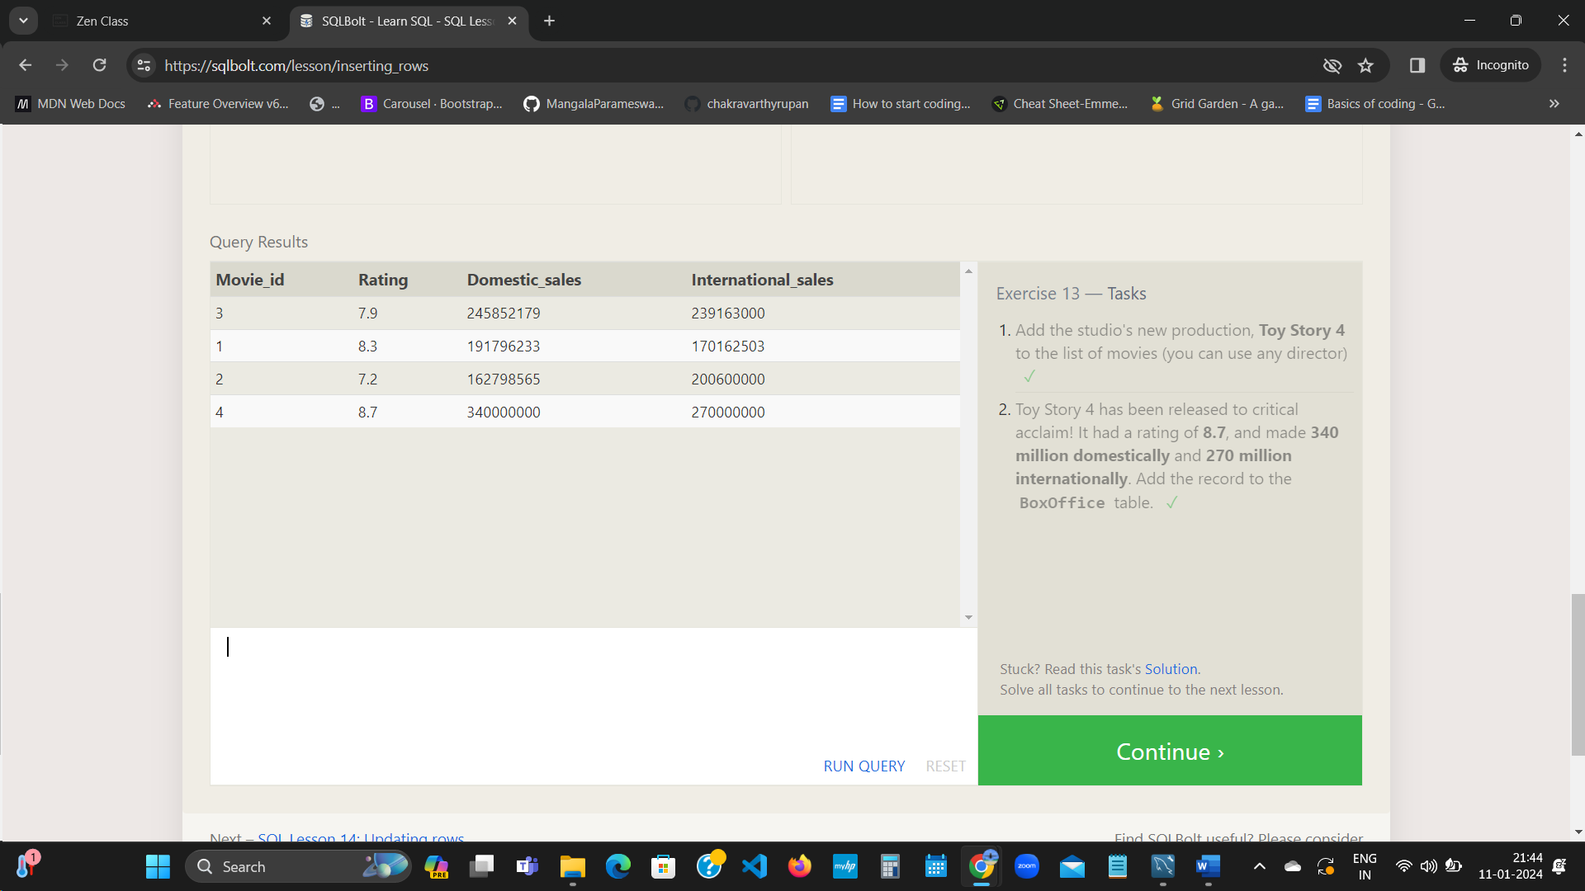 **SQL Lesson 14: Updating rows**

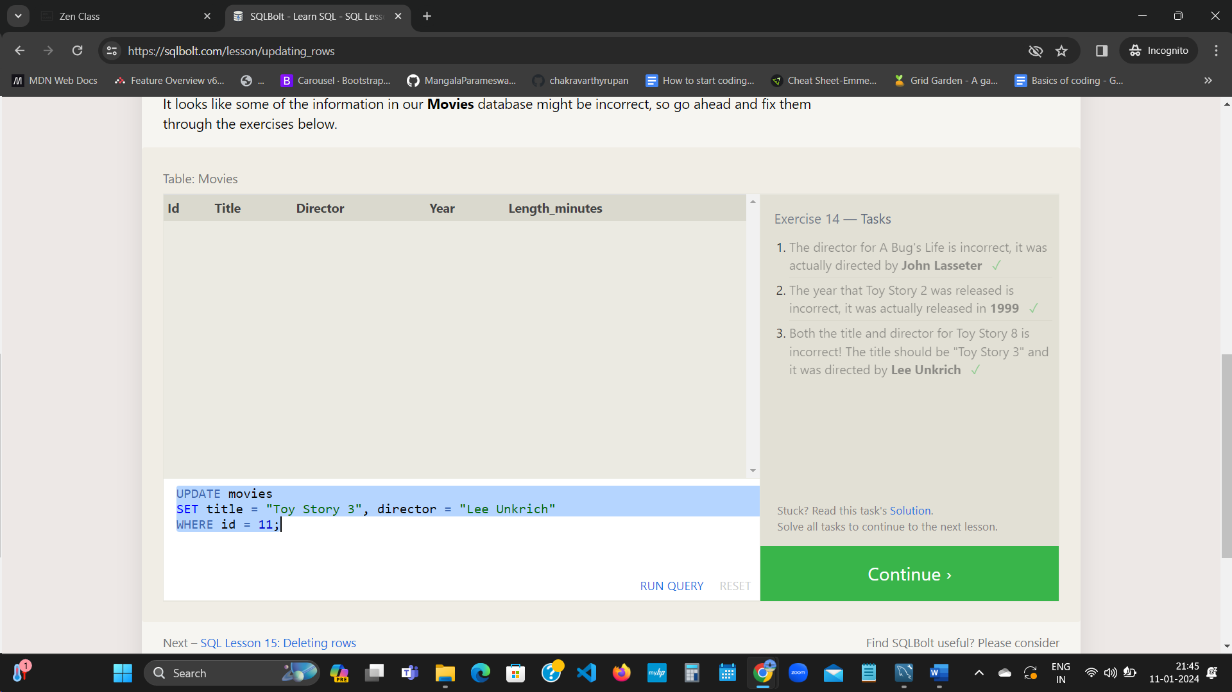 **SQL Lesson 15: Deleting rows**

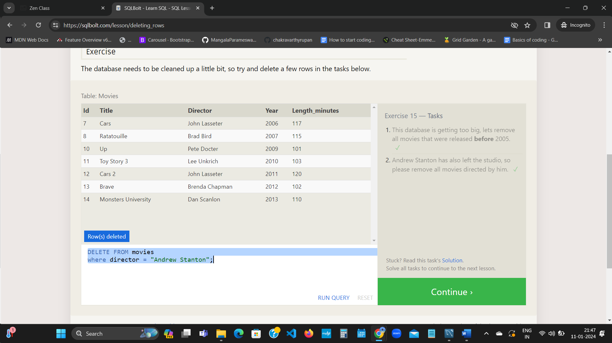 **SQL Lesson 16: Creating tables**

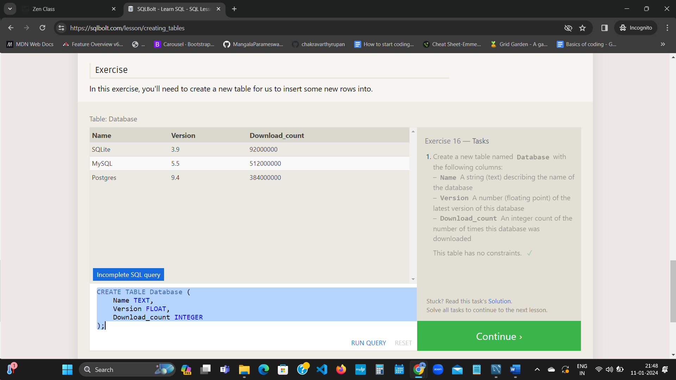 **SQL Lesson 17: Altering tables**

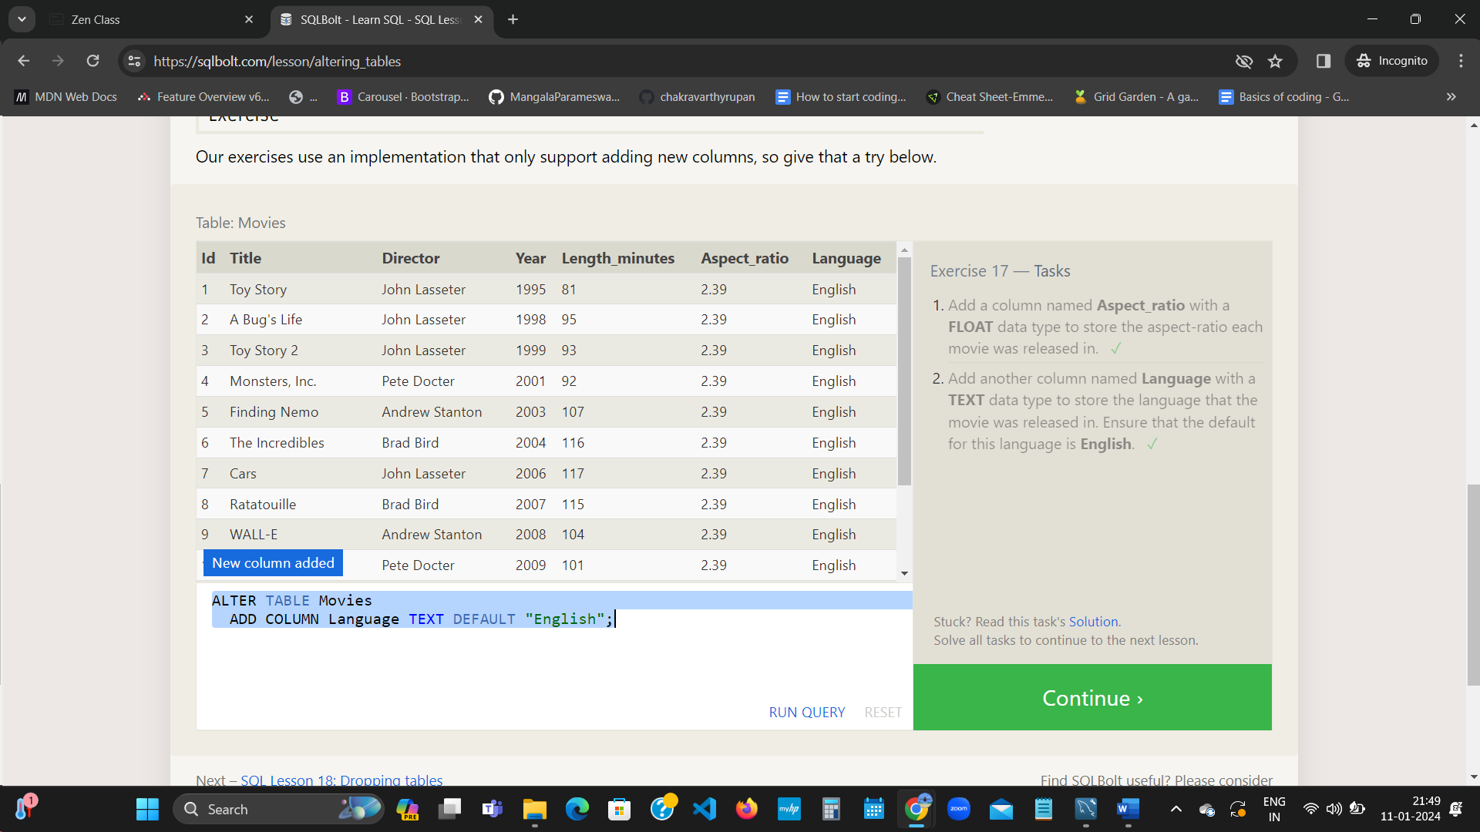 **SQL Lesson 18: Dropping tables**

